Project Design Phase-II
Data Flow Diagram & User Stories

Date | 29 September 2026
Team ID | SWTID-2026-9956
Project Name | Auto Ticket Classification Using Flow Designer
Maximum Marks | 4 Marks

Data Flow Diagrams:
A Data Flow Diagram (DFD) is a traditional visual representation of the information flows within a system. A neat and clear DFD can depict the right amount of the system requirement graphically. It shows how data enters and leaves the system, what changes the information, and where data is stored.
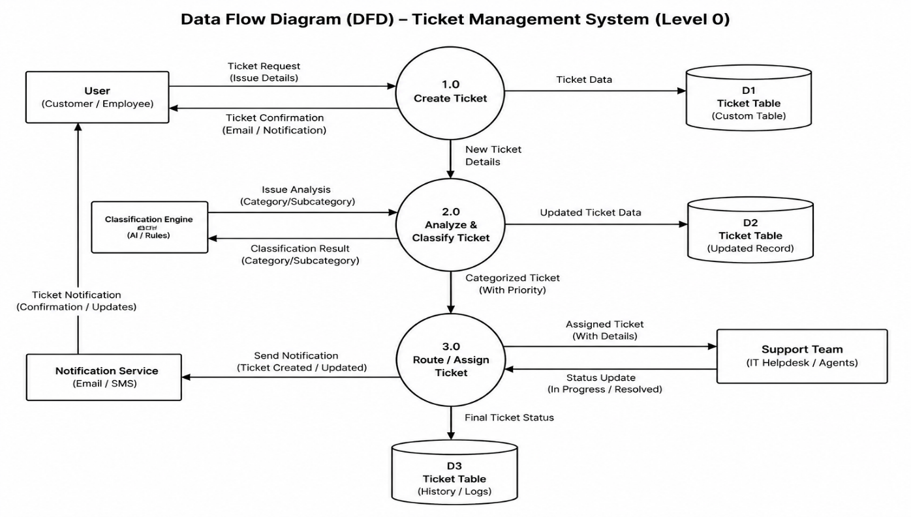

User Stories
Use the below template to list all the user stories for the product:

User Type | Functional Requirement (Epic) | User Story Number | User Story / Task | Acceptance Criteria | Priority | Release
IT Administrator | Custom Ticket Management | USN-1 | As an administrator, I can create a custom table to store ticket information in a structured format. | The custom table contains all required ticket fields. | High | Sprint-1
Customer / Caller | Ticket Creation | USN-2 | As a customer, I can create an IT support ticket by providing my issue description. | The ticket is successfully created with the submitted issue details. | High | Sprint-1
IT Support Staff | Automatic Classification | USN-3 | As an IT support staff member, I can have the system automatically classify the ticket based on the issue description. | The correct Category and Subcategory are assigned automatically. | High | Sprint-1
Customer / Caller | Automated Notification | USN-4 | As a customer, I can receive an automated email notification when my ticket is created. | A confirmation email containing the ticket information is sent automatically. | High | Sprint-2
IT Administrator | System Maintenance | USN-5 | As an administrator, I can easily update Categories, Subcategories, and ticket fields when requirements change. | Changes can be made without redesigning the entire ticket management system. | Medium | Sprint-2

